**Name: Angeline D. Bumanglag BSCS – C203**

**MIDTERM TASK #3**

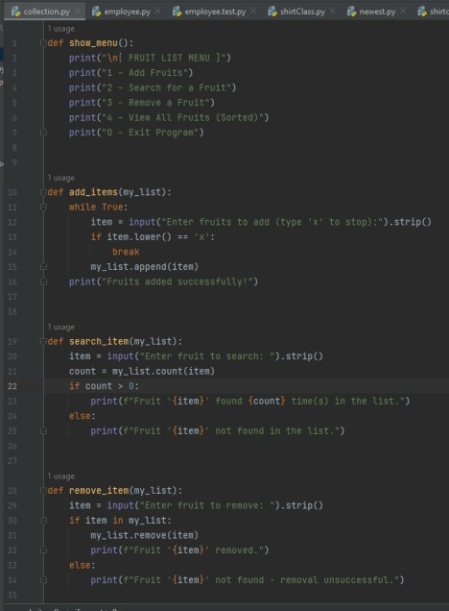

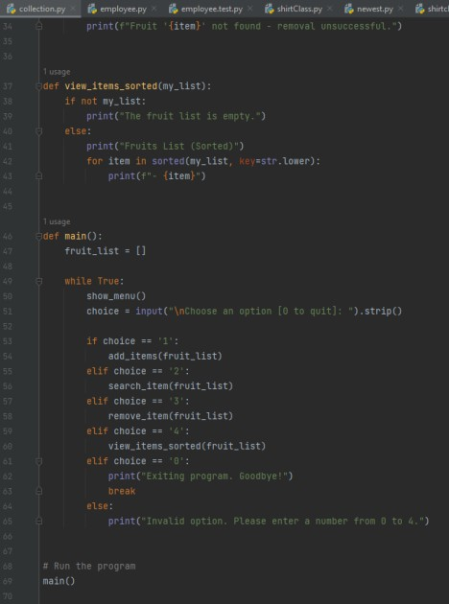

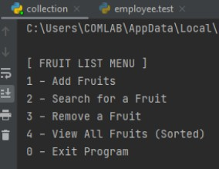

1. The user can add items in the list until the user presses x to stop

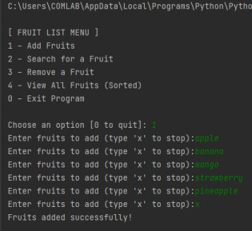

1. The user should be able to perform **search** if an item exists – Display if found or not found and count the number of instance in the list.

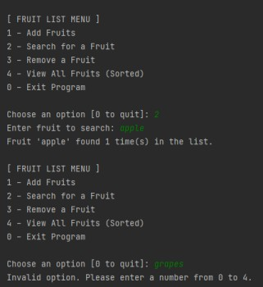

1. The user should also be given the option to **remove** an item in the list – Display the Message “Item found and deleted” once deletion is performed – else display “item not found-deletion unsuccessful”

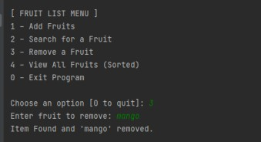

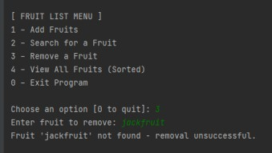

1. The user may also opt to view items in the list and display items sorted in Ascending order

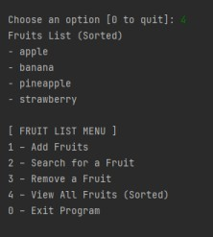

1. The user may opt to exit the program by typing 0

